Array Container hold or store similar type (int, Boolean, Employee, Account, String, Delivery, Invoice, Notification, User etc…) of data.

Easy to use(access).
Fix in size once you create an array, it can not be changes.
Index based
0 1 2 3 4 5 6

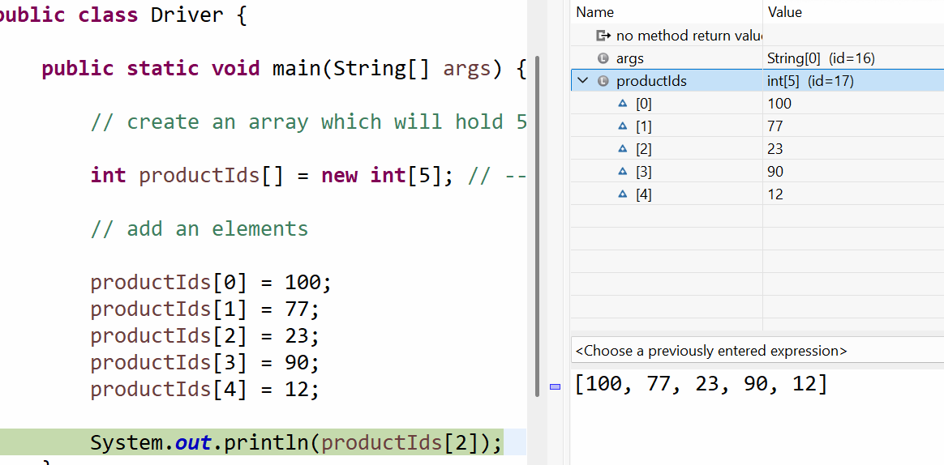
O(1) random read.

Req : You want to repeat the same logic again and again.

Check if number is greater than 21 or not 100 times
Loop in java
- For loop
- While loop
- Do while loop

Write a program to explore for loop.
Requirement: You have SBI bank customers and following are the attributes of customer.
- Customer name
- Account balance
- Mobile number
You need to find the customers whose balance is less than 2000. Print the name and balance of the customers.

